ACLS 2026 Study Guide

Basic Life Support

- C-A-B (compression – airway – breathing).
- Upon finding the victim:
- Look at the patient’s chest for normal breathing, abnormal breathing (agonal gasps) count as no breathing, if no breathing is detected you will give 2 breaths after 30 compressions. At the same time you are looking for breathing start your pulse check for 5 – 10 seconds
- If no pulse, begin CPR:
- Do 30 compressions.
- Rate must be at least 100 a minute but no more than 120 a minute.
- Compression depth for adults at least 2 inches but no more than 2.5 inches (5-6 cm).
- Open the airway.
- Give 2 breathes over 1 second each and only enough air to make the chest rise.
- Allow for full chest recoil between each compression.
- Repeat chest compressions, open the airway and give 2 breaths for a total of 5 cycles, equaling 2 minutes then check the patient and change compressors.
- Compressions are never to be stopped for longer than 10 seconds during resuscitation.
- CPR should not be interrupted except when help arrives with the AED. You can stop to attach the AED, let it analyze, and shock if needed. CPR should be continued while defibrillator is readied if there are other health care providers to set it up.
- If the victim has abnormal breathing or is not breathing and a suspected ingestion of opioid is possible the trained BLS rescuer may give Naloxone (Narcan) 0.4 mg IM or 2 mg intranasal (IN).
- For suspected spinal cord injuries the lay rescuer may immobilize the spine with their hands rather than using immobilization devices.
- Adult CPR with an advanced airway: 100-120 compressions a minute 1 breath every 6 seconds

Team Dynamics

All team members should use Closed Loop Communication during codes. By giving and receiving clear responses the team leader confirms that the team member heard and understood the message.

If a team member is about to make a mistake the team leader or another member of the team needs to address the team member immediately.

Team members must question orders if the slightest doubt exists so there is no unclear communication.

The team leader must clearly delegate tasks to avoid inefficiencies during CPR.

Everyone on the team should know their own limitations and capabilities, if an assigned task is beyond the team member’s scope of practice, they should tell the team leader and ask for a new task or role.

Continuous Quantitative Waveform Capnography is used to measure exhaled CO2 (PETCO2)

The American Heart Association recommends continuous waveform capnography in addition to clinical assessment as the most reliable method of confirming and monitoring correct placement of an endotracheal tube. PETCO2 stands for partial pressure of end- tidal carbon dioxide.
- During CPR, PETCO2 has been shown to reflect the quality of chest compressions. The exhaled CO2 during CPR should measure at least 10 mm/Hg if compressions are adequate.
- With return of spontaneous circulation (ROSC) the capnography should read 35 – 45 mm/Hg and stay at that level as long as the patient is intubated. If the exhaled CO2 level drops, the ET tube may have become dislodged.
- The patient must have an advanced airway in place to use Capnography monitoring.
- Although capnography to confirm and monitor correct placement of supraglottic airways has not been studied, effective ventilation through these devices (laryngeal mask airway, laryngeal tube or esophageal-tracheal tube) should result in a capnography waveform during CPR and after ROSC.
- Ultrasound has now been added as an additional method of confirmation of endotracheal tube placement.

Supplemental Oxygen

- If a patient has an SPO2 of greater than 90% supplemental O2 is not necessary, if the patient is not having difficulty breathing and is not symptomatic. Oxygen should be given to patients with acute cardiac symptoms or respiratory distress.
- The lowest amount of supplemental O2 should be used to achieve an SPO2 of greater than 90%
- Excessive ventilation increases intrathoracic pressure, decreases venous return to the heart, and diminishes cardiac output and survival.
- Maximum FiO2 should be used during CPR but oxygen should be titrated after return of spontaneous circulation (ROSC).

Ventricular Fibrillation / Pulseless Ventricular Tachycardia

- Do CPR while defibrillator is readied
- 1st defibrillation at 120 – 200 joules depending on defibrillator manufacturer recommendation. Escalate joules with additional shocks up to 360 joules.
- Immediately after first defibrillation do 2 full uninterrupted minutes of CPR (5 cycles), don’t take the time to check a pulse or give breaths, start with chest compressions.
- Draw up epinephrine during this first cycle.
- Charge monitor and increase biphasic jouls
- Check Rhythm while rotating compressors and SHOCK if indicated
- Immediately do 2 minutes of CPR and administer epinephrine
- Draw up antiarrhythmic agent.
- Charge the Monitor at 1minute 145 second mark
- 3rd defibrillation at 360 joules.
- Immediately do 2 minutes of CPR and give antiarrhythmic agent.
- Draw up epinephrine.
- Check patient and repeat sequence shocking at 360 joules with each defibrillation.
- If an advanced airway is placed (endotracheal tube, combitube, King Airway or LMA) ventilations become asynchronous to compressions and the compressor does not pause for ventilations. The ventilator must give 10 breaths per minute or 1 breath every 6 seconds. Avoid excessive ventilation, which can prevent oxygen from reaching the brain.
- If the cause of the cardiac arrest is thought to be reversible venoarterial extracorporeal oxygenation (ECMO) is a possible alternative to conventional CPR
Drugs
1. Vasopressor agents:
- Epinephrine 1 mg IV q 3-5 minutes while the code is going on
2. Antiarrhythmic agent:
- Amiodarone 300 mg IV bolus, may repeat the bolus at 150 mg in 3-5 minutes if needed (the time on the dosage for Amiodarone for a patient with a pulse is 10 minutes).
- Lidocaine 1-1.5 mg/kg IV bolus

Asystole / Pulseless Electrical Activity (PEA)
- Basic life support as above except no defibrillation
- Stop every 2 minutes to check the patient (must check pulse every time if situation is PEA).
- Drugs
- Epinephrine 1 mg IV q 3-5 minutes throughout the code. Give this as soon as possible.
- Atropine and vasopressin are no longer recommended in the management of asystole or PEA.
Bradycardia
1. Rhythms:
- Sinus Bradycardia
- Junctional Escape rhythm
- 1st degree AV Block
- 2nd degree Type 1 AV Block
- 2nd degree Type 2 AV Block
- 3rd Degree AV Block
- pacemaker failure

3. Drugs
- If patient is symptomatic you must speed up heart rate (always titrating to a
heart rate of at least 60 or until an arrhythmia occurs)
1. Atropine 1 mg q 3-5 minutes to a total of 3 mg
2. Dopamine gtt @ 5-20 mcg/kg/min
3. Epinephrine gtt @ 2-10 mcg/min
Tachycardia
1. Any unstable patient in tachycardia must be Synchronized Cardioverted
starting energy levels (heart rates greater than 150):
- Narrow Regular 50-100
- Narrow irregular 120-200
- Wide Regular 100 Joules
2. Rhythms:
- Fast: >150, stable, regular, narrow QRS = Reentry SVT or 2:1 A Flutter
- Fast >150, stable, irregular, narrow QRS = Atrial fibrillation or A Flutter
- Fast: > 150, stable, regular, wide QRS = V Tach or SVT w/ aberrancy
- Fast: >150, stable, irregular, wide QRS = V Tach or A Fib or A Flutter w/aberrancy
3. Drugs used if patient is stable:
- Reentry SVT: Try vagal maneuvers first, if not successful give Adenosine 6 mg rapid IV push; may repeat in 1-2 minutes with 12 mg. Adenosine must be followed by a rapid physical 20 ml NS flush
- Atrial Fibrillation or Atrial Flutter: Control with Cardizem 10 mg IVP slowly, may repeat if needed and if successful hang a drip @ 10 mg/hr.
- Possible Reentry SVT with aberrancy = Wide complex, regular monomorphic tachycardia which may have originated above the ventricles and is conducted aberrantly through the ventricular conduction system you may try to Ablate w/ adenosine (do not use if rhythm is irregular) If adenosine doesn’t work change to Amiodarone 150mg over 10 minutes to ablate the V Tach.
- Possible A Fib/Flutter with aberrancy = Wide complex irregular tachycardia which may have originated above the ventricles and is conducted aberrantly through the ventricular conduction system you may try to Control this with Cardizem 10 mg, may repeat and if successful follow with a drip.

Return of Spontaneous Circulation (ROSC)
- After return of spontaneous circulation in patients whom coronary occlusion is suspected out of
hospital providers should take the patient to a hospital with a cardiac catheterization lab for coronary reperfusion. The first treatment priority for the patient who achieves ROSC is to optimize
ventilation and oxygenation.
2. After achieving ROSC the arterial oxyhemoglobin saturation should be monitored
and titrated to maintain a target O2 saturation of 90-98%. The minimum acceptable systolic BP post
cardiac arrest is 90 mm/Hg with a mean arterial pressure (MAP) of greater than 65. If the pt is
hypotensive and you intervene titrate your treatment to a map 65mmhg
- Fluid Bolus of 1 - 2 Liters of NS
- Dopamine gtt 2 - 10- mcg/kg/minute
- Epinephrine gtt @ 0.1 – 0.5 mcg/kg/min
- Control temperature to optimize neurological recovery. Therapeutic hypothermia is the only
intervention demonstrated to improve neurologic recovery after cardiac arrest.
Therapeutic Hypothermia should be initiated if the patient has ROSC with GCS of less than 8.
Patient must be unconscious, intubated, sedated, and on the ventilator.
- Begin cooling process within time limits set by your institution, usually there is a 6 hour time limit after return of ROSC to start this
- Place the patient on a cooling machine and reduce temperature to 32 – 37.5 degrees Celsius
- Keep patient cooled for 24 hours and start the rewarming as dictated by your hospital protocols. A 72-hour time period after cooling should be considered before considering patient eventual status.
- Anticipate, treat and prevent multiple organ failure (including avoiding excessive ventilation).
Anticipate a decreased heart rate, decreased phosphate and potassium concentration, decreased
gut motility. Expect an increase in clotting times, blood glucose, vascular resistance, solubility of gases.
- Be cautious of hypothermia in patients with intracranial hemorrhage, major surgery less than 14 days (increased risk of infection/bleeding), systemic infection/sepsis (inhibits immune function), known bleeding disorders or active bleeding, temperature less than 30°C after cardiac arrest
Acute Coronary Syndrome (ACS)
1. Patients must be transported to a facility which has an organized system to care for
ST segment Elevation Myocardial Infarctions (STEMI).
2. Patients should be triaged to a hospital capable of performing percutaneous coronary interventions
(PCI). This is a mechanical means to open an occluded coronary artery, which can allow balloon
dilation and/or stent placement.
3. Therapy for reperfusion must be initiated: pre-hospital recognition of STEMI with notification of the
Catheterization lab decreases time to reperfusion. Since PCI has become readily available in many
places quick transfer without fibrinolysis improves reperfusion and decreases the risk of
bleeding. When timely transfer for reperfusion cannot take place fibrinolysis then transfer is
acceptable as an alternative.
- Door to balloon inflation equal to or less than 90 minutes
- Door to Drug started less than 30 minutes
4. Patients may be cooled while receiving PCI or drug therapy.
5. Do not use morphine in any patient who is hypotensive or hypovolemic (RVMI).
6. Recommended dose of aspirin for a patient with suspected acute coronary syndrome 160 to 325 mg
7. Supplemental oxygen is not necessary if O2 sat is greater than 94% and the patient is not having
difficulty breathing or complaining of chest pain.
- Consider reversible causes if the patient is unstable. Thrombolysis and thrombectomy are reasonable
emergency treatments in cases or arrest due to pulmonary embolism (PE). Thrombolysis may also be considered if PE is the most likely cause. If the cause of the cardiac arrest is due to a drug overdose (anesthetics) consider treatment with intravenous Lipid emulsion.
Hs Ts
Hypovolemia Tension Pneumothorax
Hypoxia Tamponade, Cardiac
Hydrogen Ion Toxins
Hypo-Hyperkalemia Thrombosis, Cardiac
Hypothermia Thrombosis, Pulmonary

Stroke
- EMS should alert the hospital and bring patients to the closest appropriate facility with a Stroke Center being preferred. New stroke triage algorithm for ems destination should be followed. Patient outcomes improve when care is provided on a dedicated stroke unit by a multidisciplinary team.
2. Pre hospital treatment of blood pressure is not necessary unless the patient is hypotensive.
3. A non-contrast CT should be done within 25 minutes of the patient arriving to the hospital
4. Patients should be treated with tPA:
- If they present within 3 – 4.5 hours of the onset of neuro deficits and a diagnosis of ischemic stroke. Start the fibrinolytic therapy as soon as possible
- endovascular therapy time is now up to 24 hours
- Both Alteplase and endvascular therapy can be given to those, who meet criteria.
Miscellaneous:
1. If an AED says “no shock advised” (and pt is unresponsive and pulseless) do CPR.
2. When suctioning an intubated pt apply suction while withdrawing catheter for no longer than 10 seconds.
3. Securing ET tube ties too tightly around the neck may decrease venous return from the brain.
4. Ventilation rate for a patient with a pulse is 10 - 12 breaths per minute (1 breath every 5 – 6 seconds).
5. If rigor has set in CPR should not be started.
6. In a patient that has a strong pulse and becomes apneic, then begins to have a rate that begins to slow you
should fix respirations first.
7. An unstable patient in tachycardia should be cardioverted. If the patient is stable do an EKG first.
8. The role of the Rapid Response Team (RRT), is to identify and treat early clinical deterioration.
9. Oxygen should not be blowing over the patient’s chest when defibrillating.
10. An oropharyngeal airway is measured from the corner of the mouth to the angle of the mandible.
11. Manual left uterine displacement should be used with high quality CPR in a pregnant patient.
12. For cardiac arrest in pregnant women with probable fetal viability a perimortem C-section should be
13. A new algorithm for cardiac arrest in pregnant women has been releasesd

General Rhythm Rules
Sinus Rhythm
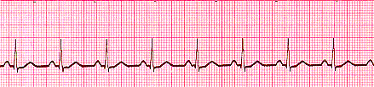

If you see this on a monitor you still have to check for a pulse, if you do not feel a pulse this is called pulseless electrical activity (PEA) and you have to look for underlying causes.
- Rhythm - Regular
- Rate -60-99 beats per minute (bpm)
- QRS Duration - Normal
- P Wave - Visible before each QRS complex
- P-R Interval - Normal (<5 small Squares. Anything above and this would be 1st degree block)

Sinus Bradycardia
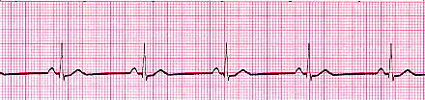

Heart rate less than 60 beats per minute (BPM). In healthy person may be 'normal', but other causes may be due to patients on beta blockers, increased vagal tone from drug abuse, hypoglycemia and brain injury with increase intracranial pressure (ICP)
Rhythm - Regular
Rate - less than 60 beats per minute
QRS Duration - Normal
P Wave - Visible before each QRS complex
P-R Interval - Normal

Sinus Tachycardia
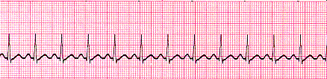

Heart rate above 100 beats per minute originates from the SA node. Causes include stress, fright, illness and exercise. Not a surprise if triggered in response to regulatory changes e.g. shock. The impulse generating the heartbeats is normal, but occurring at a faster pace than normal.
Rhythm - Regular
Rate - More than 100 but usually less than 150 beats per minute
QRS Duration - Normal
P Wave - Visible before each QRS complex
P-R Interval - Normal

Supraventricular Tachycardia (SVT)
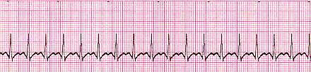

A narrow complex tachycardia or atrial tachycardia originates in the 'atria' but is not under direct control from the SA node. SVT can occur in all age groups
Rhythm - Regular
Rate - 140-220 beats per minute
QRS Duration - Usually normal
P Wave - Often buried in preceding T wave
P-R Interval - Depends on site of supraventricular pacemaker
Impulses stimulating the heart are not being generated by the sinus node, but instead are coming from a collection of tissue around and involving the atrioventricular (AV) node

Atrial Fibrillation
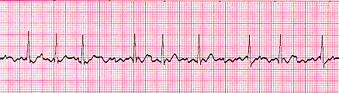

Many sites within the atria are generating their own electrical impulses, leading to irregular conduction of impulses to the ventricles that generate the heartbeat. This irregular rhythm can be felt when palpating a pulse. It may cause no symptoms, but it is associated with palpitations, fainting, chest pain, or congestive heart failure.
Rhythm - Irregularly irregular
Rate - usually 100-160 beats per minute but slower if on medication
QRS Duration - Usually normal
P Wave - Not distinguishable as the atria are firing all over
P-R Interval - Not measurable
The atria fire electrical impulses in an irregular fashion causing irregular heart rhythm

Atrial Flutter
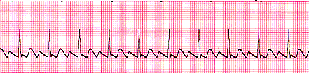

Rhythm - Regular
Rate - Around 110 beats per minute
QRS Duration - Usually normal
P Wave - Replaced with multiple F (flutter) waves, usually at a ratio of 2:1 (2F - 1QRS) but sometimes 3:1
P Wave rate - 300 beats per minute
P-R Interval - Not measurable
As with SVT the abnormal tissue generating the rapid heart rate is also in the atria, however, the atrioventricular node is not involved in this case.

1st Degree AV Block
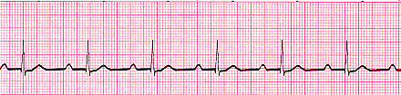

1st Degree AV block is caused by a conduction delay through the AV node but all electrical signals reach the ventricles. This rarely causes any problems by itself and athletes can have it. The normal P-R interval is between 0.12s to 0.20s in length, or 3-5 small squares on the ECG.
Rhythm - Regular
Rate - Normal
QRS Duration - Normal
P Wave - Ratio 1:1
P Wave rate - Normal
P-R Interval - Prolonged (>5 small squares)

2nd Degree Block Type 1 (Wenckebach)
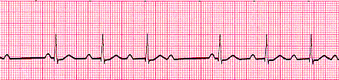

Conduction block, not all atrial beats getting through to the ventricles. There is progressive lengthening of the PR interval and then failure of conduction of an atrial beat, shown by a dropped QRS complex.
Rhythm - Regularly irregular
Rate - Normal or Slow
QRS Duration - Normal
P Wave - Ratio 1:1 for 2,3 or 4 cycles then 1:0.
P Wave rate - Normal but faster than QRS rate
P-R Interval - Progressive lengthening of P-R interval until a QRS complex is dropped

2nd Degree Block Type 2
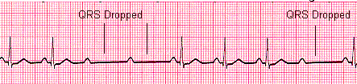

When electrical excitation fails to pass through the A-V node or bundle of His, this intermittent occurance is called Second Degree heart block. Electrical conduction usually has a constant P-R interval, in the case of type 2 block atrial contractions are not regularly followed by ventricular contraction
Rhythm - Regular
Rate - Normal or Slow
QRS Duration - Prolonged
P Wave - Ratio 2:1, 3:1
P Wave rate - Normal but faster than QRS rate
P-R Interval - Normal or prolonged but constant

3rd Degree Block
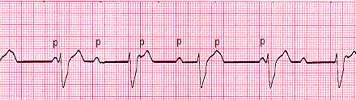

3rd degree block or complete heart block occurs when atrial contractions are 'normal' but no electrical conduction is conveyed to the ventricles. The ventricles then generate their own signal through an'escape mechanism' from a focus somewhere within the ventricle. The ventricular escape beats are usually 'slow'
Rhythm - Regular
Rate - Slow
QRS Duration - Prolonged
P Wave - Unrelated
P Wave rate - Normal but faster than QRS rate
P-R Interval - Variation
Complete AV block. No atrial impulses pass through the atrioventricular node and the ventricles generate their own rhythm

Bundle Branch Block
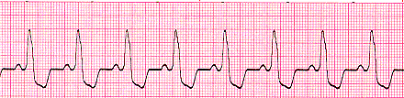

Abnormal conduction through the bundle branches cause a depolarization delay through the ventricular muscle, this delay shows as a widening of the QRS complex. Right Bundle Branch Block (RBBB) indicates problems in the right side of the heart; Left Bundle Branch Block (LBBB) is an indication of heart disease. If LBBB is present then further interpretation of the ECG cannot be carried out. A 12 Lead EKG is needed if this is a new finding
Rhythm – May be Regular
Rate – May be Normal
QRS Duration - Prolonged
P Wave - Ratio 1:1
P Wave rate - Normal and same as QRS rate
P-R Interval – Normal

Premature Ventricular Complexes
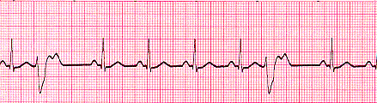

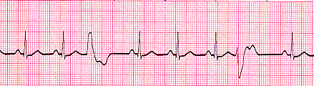

Due to a part of the heart depolarizing earlier than it should
Rhythm - Variable
Rate – Variable
QRS Duration - Normal
P Wave - Ratio 1:1
P Wave rate – May be normal and same as QRS rate
P-R Interval - Normal
In these strips you'll see 2 odd waveforms, these are the ventricles depolarizing prematurely in response to a signal within the ventricles. Unifocal PVC's look alike, if they differ in appearance called multifocal PVC's meaning more than one irritable focus in the heart.

Junctional Rhythms
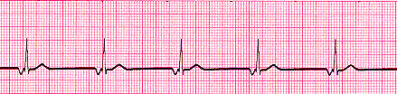

In a junctional rhythm the sinoatrial node does not control the heart's rhythm - this can happen in the case of a block in conduction somewhere along the pathway. When this happens, the heart's atrioventricular node takes over as the pacemaker.
Rhythm - Regular
Rate - May be 40-60 beats per minute
QRS Duration - Normal
P Wave - Ratio 1:1 if visible. Inverted in lead II
P Wave rate - Same as QRS rate
P-R Interval - Variable

Ventricular Tachycardia (VT) (Monomorphic)
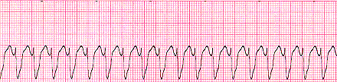

Rhythm - Regular
Rate - 180-190 beats per minute
QRS Duration - Prolonged
P Wave - Not seen
Results from abnormal tissues in the ventricles generating a rapid and irregular heart rhythm. Poor cardiac output is associated with this rhythm causing the patient to go into cardiac arrest. Defibrillate this rhythm if the patient is unconscious and without a pulse. If the patient has a pulse they must be synchronized cardioverted.

Polymorphic Ventricular Tachycardia & Torsades de Pointes (TdP)
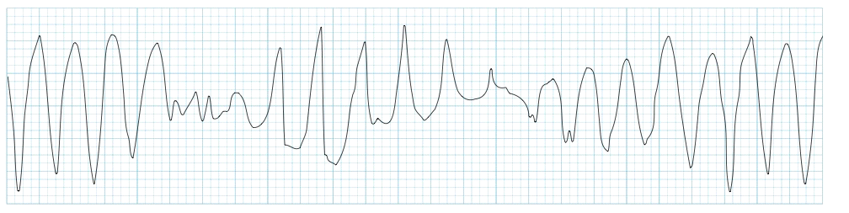

Polymorphic ventricular tachycardia (PVT) is a form of ventricular tachycardia in which there are multiple ventricular foci with the resultant QRS complexes varying in amplitude, axis and duration. The commonest cause of PVT is myocardial ischemia.
Torsades de pointes (TdP) is a specific form of polymorphic ventricular tachycardia occurring in the context of QT prolongation; it has a characteristic morphology in which the QRS complexes “twist” around the isoelectric line. It can be associated with hemodynamic instability and collapse, may also degenerate into ventricular fibrillation (VF).
QT prolongation may occur secondary to multiple drug effects, electrolyte abnormalities and medical conditions; hypokalemia may precipitate TdP in a patient with congenital long QT syndrome.
Recognition of TdP and the risk of TdP allow the instigation of specific management strategies such as magnesium.

Ventricular Fibrillation (VF)
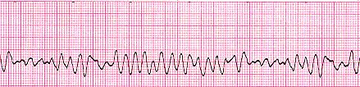

Disorganized electrical signals cause the ventricles to quiver instead of contract in a rhythmic fashion. A patient will be unconscious, as blood is not pumped to the brain. Immediate treatment by defibrillation is indicated.
Rhythm - Irregular
Rate - 300+, disorganized, no pulse is able to be felt
QRS Duration - Not recognizable
P Wave - Not seen

Asystole -
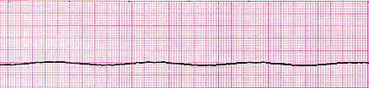

No cardiac electrical activity, no contractions of the myocardium and no cardiac output or blood flow are present. CPR must be done while looking for the underlying cause.
Rhythm - Flat
Rate - 0 Beats per minute

Myocardial Infarct (MI)
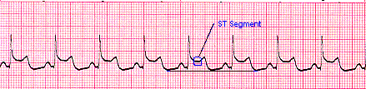

Rhythm - Regular
Rate – variable this one is 80 Beats per minute
QRS Duration - Normal
P Wave - Normal
S-T Segment is above the isoelectric baseline indicating injury. NOT diagnostic unless associated with a 12 lead ECG

