PALS Study Guide

The updates and precourse websites are elearning.heart.org and www.heart.org/courseupdates.

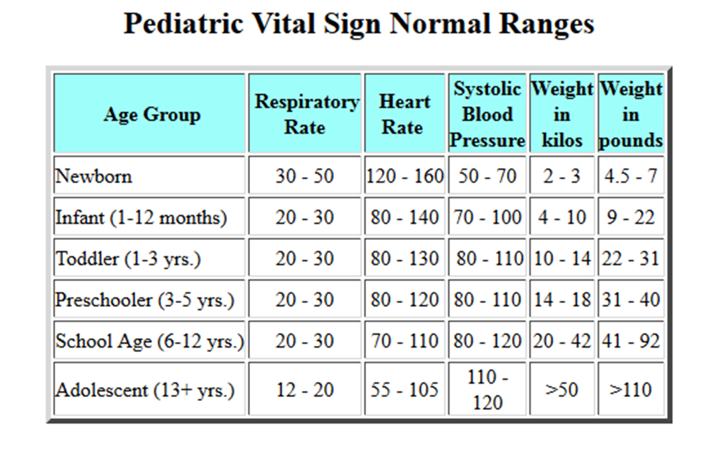

Differential Diagnosis

“H’s and T’s”, “Seek & Treat Possible Causes”, “Reversible Causes”
6Hs 5 Ts
Hypoxia Tamponade

Hypovolemia Tension pneumothorax
Hypothermia Toxins – poisons, drugs
Hypoglycemia Trauma
Hypo/hyperkalemia Thrombosis – coronary (AMI), –
pulmonary (PE)
Hydrogen ion (acidosis)

Rapid Cardiopulmonary Assessment Algorithms

This is a systematic head-to-toe assessment used to identify infants and children in respiratory distress and failure, shock, and pulseless arrest.

Algorithms are “menus” that guide you through recommended treatment interventions.

Know the following assessment because it begins all PALS case scenarios. The information you gather during the assessment will determine which algorithm you choose for the patient’s treatment.

After each intervention you will reasses the patient again using the head-to-toe assessment.

Initial Impression: Visual and auditory observation of the child's consciousness, breathing and color. From the doorway observation.

General appearance: What is the child's level of consciousness:
A= awake V= responds to verbal P= responds to pain U= unresponsive
Is the child alert, irritable or unresponsive?
How is the child's breathing: Is there increased work of breathing, absent or
decreased respiratory effort or abnormal sounds heard without auscultation.
What is the child's overall color: Is the color good or bad, flushed, or cyanotic?
Do you see mottling?
In your initial impression can you see if the child's muscle tone is:
good or "floppy”.

Assess ABCs: Stop and give immediate support when needed, then continue with assessment.

Airway:

Open and hold with head tilt-chin lift as needed. Let the child assume a position of comfort as needed.

Breathing:
See if the breathing is present or absent. Assess the rate; normal, slow or fast. Look at the pattern for regular or irregular; see if the child is gasping. Look at the depth; normal, shallow or deep, variable or always the same. Assess the sounds associated with breathing for stridor, grunting or wheezing. Assess the exertion needed for is nasal flaring, sternal retractions, or any accessory muscle use.

If there are no breath sounds on one side after a trauma a needle decompression should be done until a chest tube can be inserted. If the child develops bradycardia that is a result of a respiratory problem, administer oxygen and ensure adequate ventilation. Be prepared to intervene further if the heart rate does not increase.

Target range for oxygen saturation is 94% - 99%. Look at the child's general appearance. If a pulse oximeter is reading high but the child has signs and symptoms consistent with needing oxygen do not trust the pulse oximeter, apply the oxygen.

Rescue breaths are given at a rate of 20 to 30 a minute when the infant or child has a pulse but is not breathing (one breath every 2-3 seconds). Give each breath over one second.

Circulation:
See if the central pulse is present or absent. The rate is normal, slow or fast, the rhythm regular or irregular. After putting the patient on the monitor look at the QRS and see if it is narrow or wide.

Perfusion is part of looking at the circulation. Assess the central pulse versus peripheral pulse strength to see if it is equal or unequal. Look at the skin, check the color of the skin, note if there is a rash or pattern. Feel the skin to see if it is hot or cold; see if your patients’ temperature is normal or abnormal.

Brachial pulse checks are done on infants through age 12 months, and the maximum time spent checking for a pulse should be no more than 10 seconds.

If the infant or child has no pulse the compression ventilation ratio for one person CPR is 30 compressions to 2 breaths in 18 seconds or less. When a second rescuer arrives the ratio changes to 15 compressions to 2 breaths in 9 seconds or less.

As soon as an AED becomes available turn it on and follow the prompts. If pediatric pads are unavailable on the AED it is acceptable to use adult pads.

Defibrillation is 2J/kg for the first shock (acceptable range is 2-4J/kg) Subsequent doses are 4J/kg 6J/kg 8J/kg (not to exceed 10J/kg or standard adult dose)
If the child is in a stable SVT start with vagal maneuvers. Ice to the face is the preferred vagal maneuver for a 6-month-old. If the SVT is unstable because the child or infant is symptomatic deliver a synchronized shock at 0.5 to 1 J/kg with subsequent synchronized shocks at 2J/kg.

Check: Systolic BP (normal or compensated) acceptable for age or hypotensive.
Urine output: normal= 1– 2mL/kg/hr, (infants and children), 30mL/hr (adolescents). The BP and urine output are either adequate or inadequate.

Capillary refill must be assessed, normal is 2 seconds or less, abnormal is greater than 2 seconds.

Liver edge palpated at the costal margin is an indication that the patient may be
normal or dry. If the liver edge is below costal margin assess the child for fluid overload.

Classify the physiologic status:
Stable: Needs little support; reassess frequently.

Unstable: Needs immediate support and intervention.

Respiratory distress: Increased rate, effort, noise of breathing; requires a lot of the child's energy. Respiratory distress is characterized by an increased work of breathing.

Respiratory failure: Slow or absent rate, weak or no effort and the child may be incredibly quiet. Respiratory failure is characterized by inadequate oxygenation and/or ventilation.

Upper airway obstruction with strider and moderate retractions should have nebulized epinephrine administered.

Lower airway obstruction produces a prolonged expiratory phase and wheezing.

Disordered control of breathing may be seen after seizure activity.

Lung tissue disease in a child causing acute respiratory distress will most likely have decreased oxygen saturation as a sign.

Compensated shock: SBP is acceptable but perfusion is poor: central vs. peripheral pulse strength is unequal peripheral color is poor and skin is cool, capillary refill is prolonged. Normal blood pressure + signs of inadequate tissue perfusion = compensated shock.

Decompensated shock: Systolic hypotension with poor or absent pulses, poor color, weak compensatory effort. Hypotension + signs of poor perfusion
- decompensated shock. Immediate vascular access should be obtained by placing an intraosseous line during resuscitation or severe shock.

- Distributive Shock is subdivided into Anaphylactic shock, Neurogenic shock and Septic shock.
- Septic Shock is characterized by an infection or its by-products causing fever, vasodilation, and capillary permeability. Administer fluids at 20mL/kg normal saline.

- Hypovolemic shock is characterized by fluid volume loss. Treatment requires the restoration of fluid volumes by correction of underlying cause at 20mL/kg normal saline. If the child remains lethargic after two boluses check the glucose. If the child has lost blood it is time to consider a transfusion.

- Cardiogenic shock results from inadequate tissue perfusion secondary to myocardial dysfunction. Give smaller fluid boluses of isotonic crystalloid at 5 to 10mL/kg over a longer period such as 10 to 20 minutes.

Advanced Airway

A cuffed or uncuffed Endotracheal Tube (ET) may be used on Infants and children.

To estimate tube size:
Uncuffed: | (Age in years ÷ 4) +4 | Example: (4 years ÷ 4) | = 1 + 4 = 5
Cuffed: | (Age in years ÷ 4) +3 | Example: (4 years ÷4) | = 1 + 3 = 4

Immediately confirm tube placement by clinical assessment and a device:

Clinical assessment:

- Look for water vapor in the tube (if seen this is helpful but not definitive). Listen for
- breath sounds over stomach and the 4 lung fields (left and right anterior and
- mid-axillary).

- End-Tidal CO2 Detector (ETD): if weight >2 kg Attach between the ETT and BVM:

the center of the litmus paper should change color with each inhalation and each exhalation. Original color on inhalation = O2 is being inhaled: expected. Color change on exhalation = Tube is in trachea. Original color on exhalation = Litmus paper is wet: replace ETD. Tube is not in trachea: remove ET. Cardiac output is low during CPR.

When sudden deterioration of an intubated patient occurs, immediately check using the DOPE mnemonic:
Displaced: ET tube is not in trachea or has moved into a bronchus. The right mainstem is the most common. Verify the endotracheal tube position if the child is intubated and develops problems.
Obstruction: Consider secretions or kinking of the tube.
Pneumothorax: Consider chest trauma, barotrauma or non-compliant lung disease.
Equipment: Check oxygen source, Bag Valve Mask and ventilator.

PALS Medications

If an order is given for a medication that is the wrong dose the order must be clarified not just given correctly without the clarification.

Epinephrine: catecholamine

Increases heart rate, peripheral vascular resistance, and cardiac output; during CPR increases myocardial and cerebral blood flow.
Cardiac Arrest and bradycardia use IV/IO: 0.01 mg/kg of 1:10 000 solution Or .1mg/kg of the 1:1000 solution

* For an allergic reaction or Asthma with severe respiratory distress
Epinephrine IM. 1:1000 .01mg/kg

Amiodarone: atrial and ventricular antiarrhythmic

Slows AV nodal and ventricular conduction increases the QT interval and may cause vasodilation.
VF/PVT: IV/IO: 5 mg/kg bolus

Perfusing VT: IV/IO: 5 mg/kg over 20-60 min

Perfusing SVT: IV/IO: 5 mg/kg over 20-60 min

Max: 15 mg/kg per 24 hours

Caution: hypotension, Torsade; half-life is up to 40 days

Lidocaine: ventricular antiarrhythmic to consider when amiodarone is unavailable
Decreases ventricular automaticity, conduction and repolarization.
IV/IO: 1 mg/kg bolus q. 5-15 min for VF/VT
Perfusing VT: IV/IO: 1 mg/kg bolus q. 5-15 min
Infusion: 20-50 mcg/kg/min
Caution: neuro toxicity → seizures

Magnesium: ventricular antiarrhythmic for Torsade and hypomagnesemia
IV/IO:25-50 mg/kg over 10–20 min; give faster in Torsade
Max:2 gm
Caution: hypotension, bradycardia

Procainamide: atrial and ventricular antiarrhythmic to consider for perfusing rhythms
Perfusing recurrent VT: IV/IO: 15 mg/kg infused over 30–60 min
Recurrent SVT:
IV/IO: 15 mg/kg infused over 30–60 min
Caution: hypotension; use it with extreme caution with amiodarone as it can cause AV block or QT prolongation

Atropine: Vagolytic to consider after oxygen, ventilation and epinephrine
Blocks vagal input therefore increases SA node activity and improves AV conduction.
IV/IO: 0.02 mg/kg; may double the amount for the second dose.

Child max: 1 mg

Adolescent max: 2 mg

Caution: Do not give less than 0.1 mg, or may worsen the bradycardia

Adenosine: Drug of choice for symptomatic SVT
For injection technique Blocks AV node conduction for a few seconds to interrupt AV
node re-entry.
IV/IO: first dose: 0.1 mg/kg max: 6 mg

2nd dose: 0.2 mg/kg max: 12 mg

Caution: transient AV block or asystole; has very short half-life

Dobutamine: Synthetic catecholamine
Increases force of contraction and heart rate; causes mild peripheral dilation; may be
used to treat shock. Caution: Tachycardia.
IV/IO infusion: 2- 20 mcg/kg/min infusion

Dopamine: Catecholamine
May be used to treat shock; effects are dose dependent.
Low dose: increases force of contraction and cardiac output.

Moderate: increases peripheral vascular resistance, BP and cardiac output.

High dose: higher increase in peripheral vascular resistance, BP, cardiac work and oxygen demand.
V/IO infusion: 2–20 mcg/kg/min Caution: tachycardia

Glucose:
Increases blood glucose in hypoglycemia; prevents hypoglycemia when insulin is used to treat hyperkalemia. IV/IO: 0.5–1 g/kg; these equals: 2–4 mL/kg of D25 or 5–10 mL/kg of D10 or 10–20 mL/kg of D5 Caution: max recommended: should not exceed D25%; hyperglycemia may worsen neurological outcome.

Naloxone: Opiate antagonist
Reverses respiratory depression effects of narcotics.
< 5 yrs or 20 kg: IV/IO: 0.1 mg/kg
>5 yrs or 20kg: IV/IO: up to 2mg
Caution: half-life is usually less than the half-life of a narcotic, so repeat dosing is often required.
Sodium bicarbonate: Buffer Prolonged arrest, hyperkalemia, tricyclic overdose:
Increases blood pH to correct metabolic acidosis.

IV/IO: 1mEq/kg slow bolus administered after effective ventilation is established Caution:must flush thoroughly to avoid precipitation w/ other drugs

